PART A:

Original image:

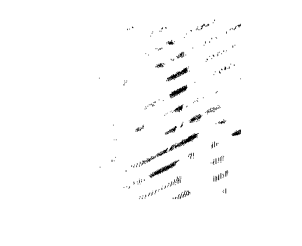

Log magnitude of FFT of image:

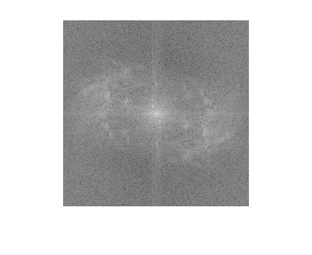

Threshold=0.3

PART B:

Denoised image:

